Section 1 TASK

Create a Dockerfile to Build the Image using Docker -> Create a file named index.html and provide the HTML contents as you prefer.

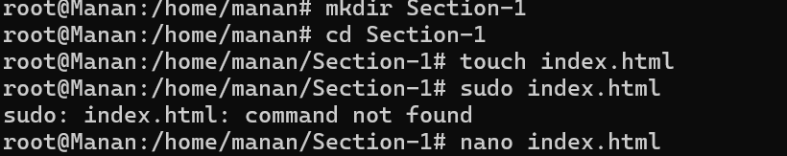

Index.html

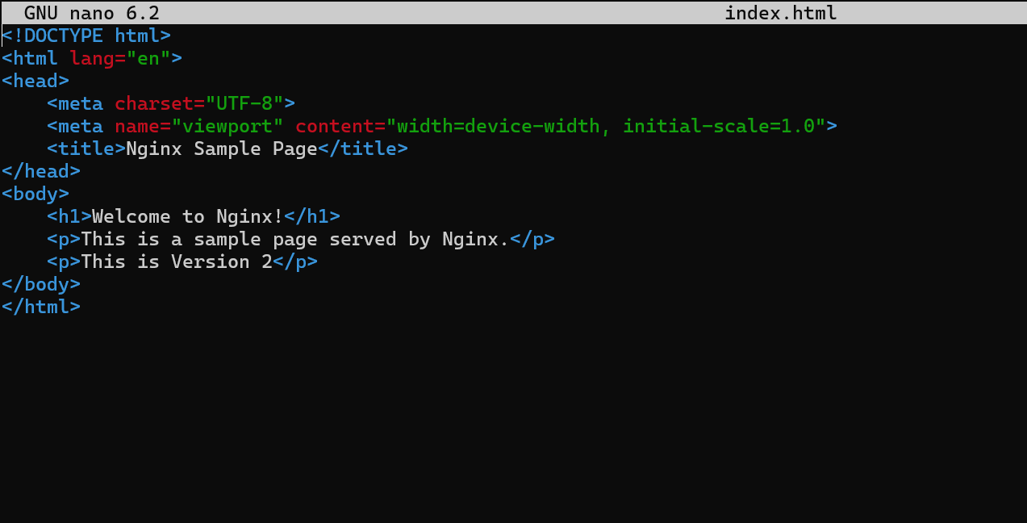

Now, create a Dockerfile with nginx latest image as base image and copy the index.html file to the container filesystem /usr/share/nginx/html ->



Dockerfile

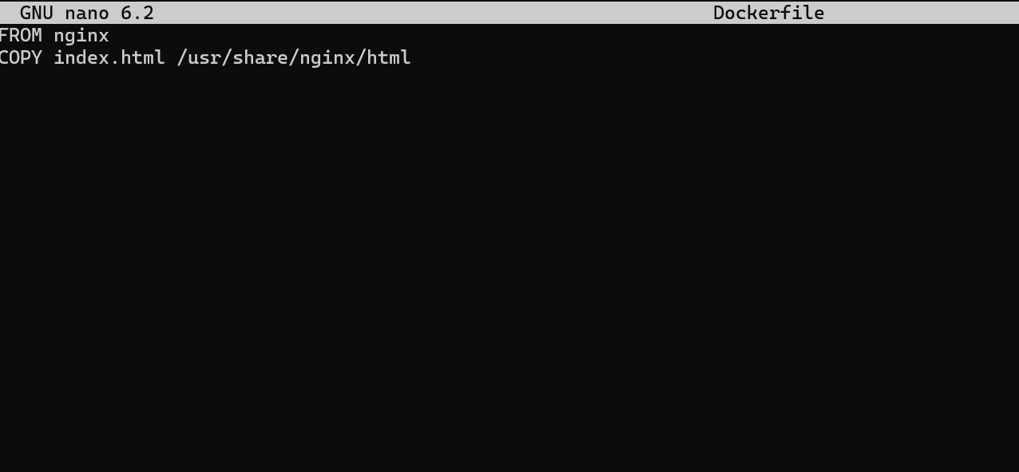

Now, Build the Image with name /nginx-sampleimage:v1

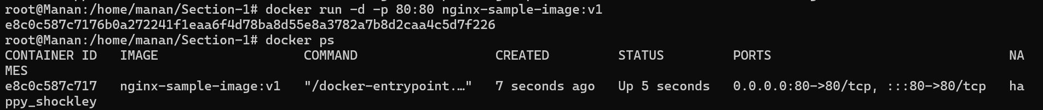

2. Create the container with the builded image and check if you are able to see the web response.

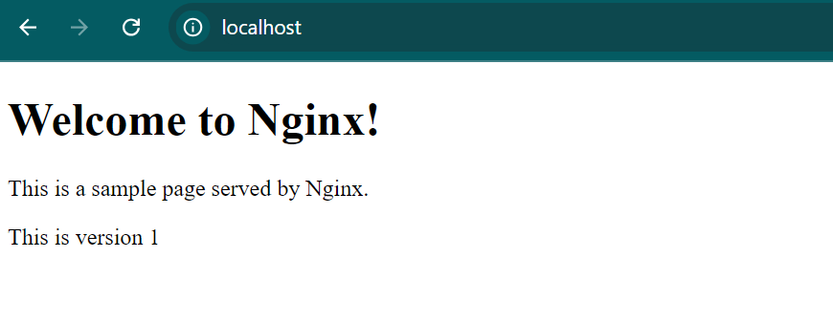

3. Go Inside the running container and check the directory /usr/share/nginx/html and display the index.html and check if the contents provided are correctly copied.

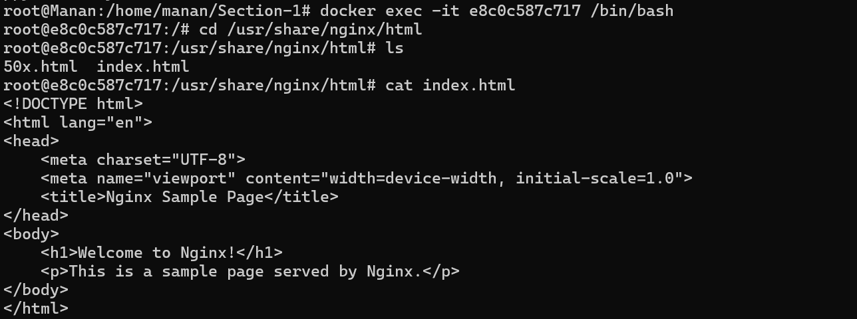

4. Now, Push the Image to you Docker Account

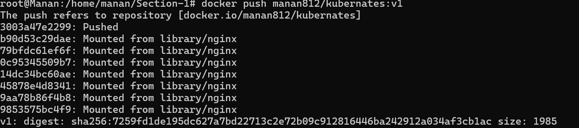

5. List the running containers in the Docker Host



6. Stop the containers running in your Docker Host

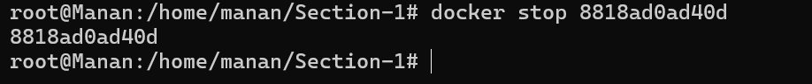

7. List the stopped containers in the Docker Host

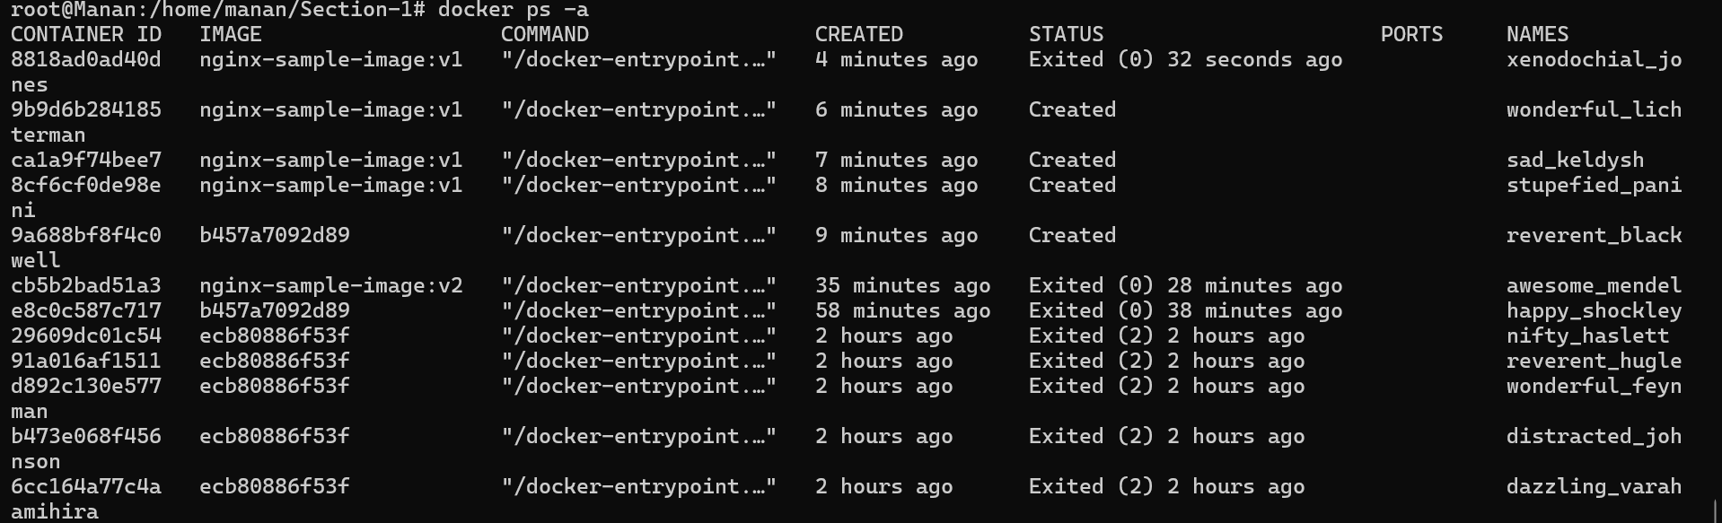

8. Pull the Nginx Image with latest tag from Docker Hub.

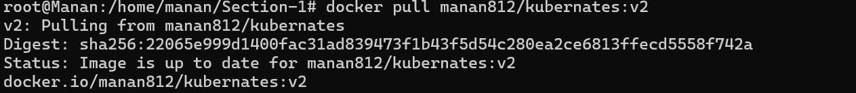

9. Run the container with Nginx Image with latest tag.



10. List all the images present in the Docker Host

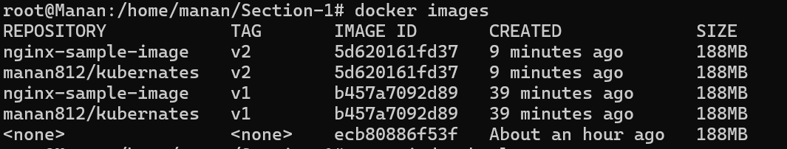

11.Delete all the images present in the Docker Host

